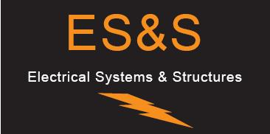
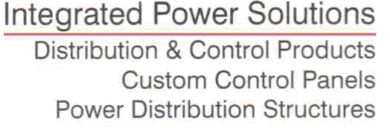

ESS Metron Proposal XXXXXX
DATE: | PAGES (including cover) 4
TO: | Phone:
ATTN: | FAX No.:
FROM: | Email:
 | Reference:

ESS Metron is pleased to offer the following proposal:

ITEM #1 4000A NEMA 3R Non Walk-in Switchgear $XX,XXX.00

Main Switchgear NEMA 3R Non Walk-in:
Electrical Rating:
- 4000A, 480/277VAC, 3phs, 4wire, 85Kaic
- UL Listed and Marked
- Service Entrance Label
- 4000Amp Plated Copper Main Bus
General Enclosure Information All Sections Combined:
- Qty vertical sections, , channel mount, Non Walk-in
- Total Switchboard Approx Dim 114”T x 54”W x 70”D
- Switchboard material -
- Channel frame material -
- Finish - - Hammer
- Color -
- Rear access required -
- Labels -
- Ground bar extending through all sections
- 3R hood with ventilation and rodent proof filters
- Exterior doors with ventilation, rodent proof filters, and stainless padlockable handles

Sectional Information:

Section 1: Main - 114”T x 32”W x 70”D
- Qty (1) circuit breaker “MAIN”: 4000AF/4000AT, 480VAC, 85kAIC, 3pole, , , 100% rated, with the following accessories:
  - 4000A rating plug
  - LSIG trip unit
  - Neutral current sensor
  - (2) Aux contacts
  - (10) #2-600MCM lugs per phase and neutral
- Qty (3) CT’s
- Qty (3) Potential Transformer, 480-120V Pri/Sec fused
- Qty (1) Control Power Transformer, 480-120V Pri/Sec fused
- Qty (1) Power Quality Meter
- Qty (1) Vestibule fluorescent light and hardware
- (1) lot section heaters with thermostat and humidistat
- Qty (1) Copper Ground Bar with (2) lugs
- Set of copper bus, splices, hardware, and bracing to connect the horizontal cross bus and ground bar between sections

Section 2: Transition - 113”T x 22”W x 70”D
- Qty (1) 4000 Amp Transition Section, cross bus connected
- Set of flex connectors for transformer connection
- (1) lot section heaters with thermostat and humidistat
- Qty (1) Copper Ground Bar with (2) lugs

Exceptions/Clarifications:
Any deviation from the scope of this proposal may result in a cost adjustment
Breaker coordination studies by others

Ship Loose Items:
- Qty (1) Breaker lifting yoke

Terms and Conditions:
COMMODITY METAL PRICE DISCLAIMER
Due to highly unstable commodity metal prices related to factors beyond our control, Metron is unable to hold its prices firm for longer than 90 days. We are making every effort to minimize the impact of such variations and appreciate your understanding. Orders placed later than 90 days after quotation are subject to a price revision based on most current metal commodity pricing.
Shipment: Approval Drawings: 2-3 weeks

Manufacturing Lead Time, 6-8 weeks after release of approved dwgs
Terms: N30
FOB: ESS Metron Inc., Denver, Colorado, shipping prepaid and allowed.
Validity: Prices Valid Thirty (30) Days From the Date of This Quotation
If you have any questions or comments please do not hesitate to contact me.

mended.

